Project Checkpoint 1 Progress Report
Project Title: Sentiment Analysis of Amazon Grocery Reviews using Distributed PySpark ML
Date: April 2, 2026
1. Dataset Acquisition & Preprocessing
The dataset for this project has been successfully acquired and validated. We are utilizing the Amazon Reviews 2023 dataset, specifically the "Grocery and Gourmet Food" category, which contains approximately 14.3 million reviews. We originally intended on doing the electronics category, however it held over 50 million reviews, which would require a very large cluster setup to run efficiently.
To handle the scale of this data efficiently, we implemented a streaming data ingestion approach using the Hugging Face datasets library. This allows us to pull data directly into our Spark environment without requiring local storage for the raw 5.97 GB file.
The preprocessing pipeline has been fully implemented in PySpark and includes the following steps:
- Filtering: Neutral reviews (3-star ratings) are removed to frame the problem as a clear binary classification task.
- Label Creation: Star ratings of 4.0 and 5.0 are mapped to a positive sentiment label (1), while ratings of 1.0 and 2.0 are mapped to a negative sentiment label (0).
- Text Cleaning: All review text is converted to lowercase and stripped of punctuation using regular expressions to prepare it for tokenization.
2. Cluster Setup & Configuration
The distributed computing environment has been successfully established on Google Cloud Platform (GCP). The system utilizes a Dataproc cluster configured specifically to handle the memory demands of the Spark ML pipeline.
The cluster specifications are as follows:
- Framework: Managed Apache Spark via GCP Dataproc
- Architecture: Single Node (Master acting as worker)
- Machine Type: n1-standard-4 (4 vCPUs, 15 GB RAM)
- Networking: Cloud NAT Gateway configured to allow external API access for data streaming.
- Development Environment: JupyterLab accessed via Component Gateway.

This configuration successfully resolved initial JVM out-of-memory errors initially encountered during early testing. This current setup provides sufficient headroom for the TF-IDF feature extraction process.

3. System Architecture
The data pipeline architecture has been mapped out and is attached as a separate diagram
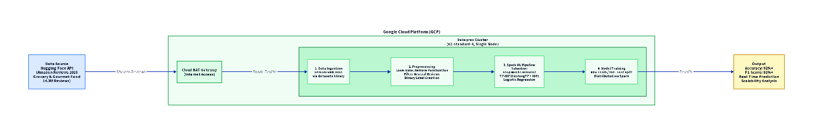
The flow begins with the Hugging Face API, streaming data through the GCP Cloud NAT into the Dataproc cluster. Within Spark, the data moves sequentially through ingestion, preprocessing, the ML pipeline (Tokenizer → StopWordsRemover → HashingTF → IDF → LogisticRegression), and finally into model training and evaluation.
4. Preliminary Implementation & Results
The full machine learning pipeline has been implemented and successfully executed end-to-end on subsets of the data. The pipeline splits the preprocessed data into an 80% training set and a 20% testing set.
Preliminary experiments have yielded strong initial results. On a test run utilizing 250,000 reviews, the model achieved the following performance metrics:
- Test Accuracy: 92.82%
- Test F1-Score: 92.04%
These metrics indicate that the TF-IDF and Logistic Regression approach is highly effective for this specific NLP task. Furthermore, the high F1-score confirms that the model is performing well across both positive and negative classes, rather than simply defaulting to the majority class.
5. Next Steps
With the core pipeline functional and the baseline model performing well, the next phases of the project will focus on:
- Scalability Analysis: Completing runtime measurements across increasing dataset sizes (up to 500,000+ rows) to generate the required scalability visualizations.
- Interactive Demonstration: We have implemented a real-time prediction function that allows users to input custom review text and receive instant sentiment classification.
- Literature Review: Synthesizing related academic work to frame the final technical report.

